PostgreSQL Retake Exam - 7 August 2024

StageMaster

Step into the spotlight with StageMaster - the definitive solution for managing all aspects of entertainment productions. As the director of your creative team, you'll harness the power of data to orchestrate seamless performances, coordinate talented actors, and categorize productions with precision. With StageMaster, the stage is set for unparalleled excellence in entertainment management.

Section 0: Database Overview
You are given an Entity/Relationship Diagram of the StageMaster System. This diagram illustrates the connections among different entities within StageMaster, offering a visual depiction of the database structure:
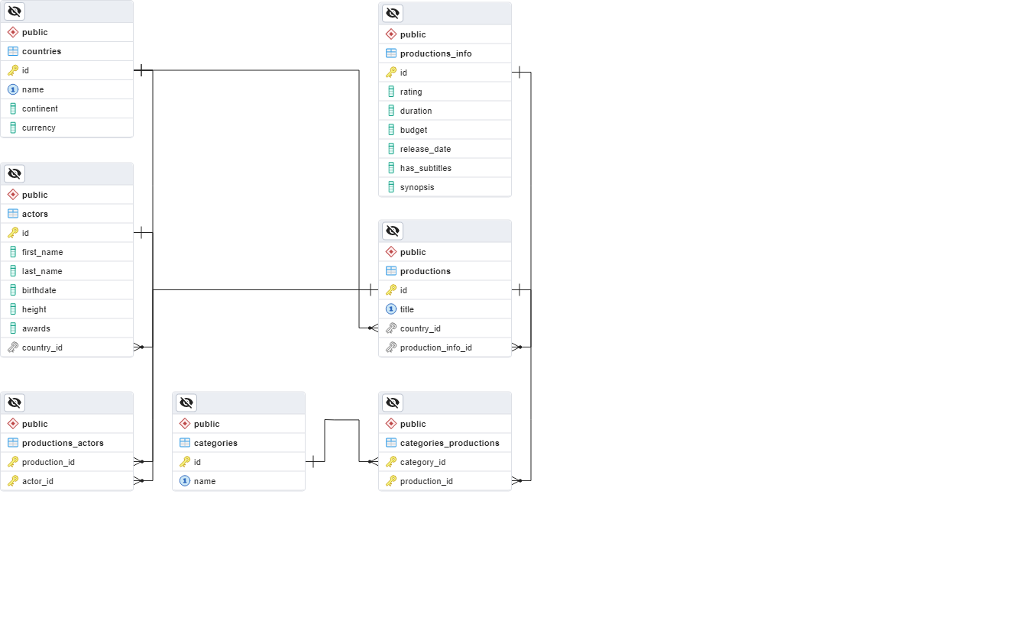
The StageMaster must contain information about productions, countries, actors, categories, and productions additional info.
Your task is to set up a database named stage_master with the following tables:
- countries - contains information about the countries.
- categories - contains information about the categories.
- actors - contains information about the actors.
- productions – contains short information about the productions.
- productions_info - contains detailed information about the productions.
- productions_actors - a many-to-many mapping table between the productions and the actors.
- categories_productions - a many-to-many mapping table between the categories and the productions.

Section 1: Data Definition Language (DDL) - 30 Pts
Make sure you implement the database tables correctly.
Important Note: When working with dates, please adhere strictly to the specified data types in the model tables. For example, if a column is defined as type 'DATE,' ensure you utilize the 'DATE' data type. Similarly, if a column is designated as 'TIMESTAMP,' use the 'TIMESTAMP' data type. Failure to use the correct data type may result in your submission being rejected by the Judge system.

Table Design
You have been tasked to create the tables in the database by following the specified models.
Submit only your CREATE statements for all tables to the Judge System.

countries
Column Name | Data Type | Constraints
id | Integer, from 0 to 2,147,483,647 | Primary Key, Unique table identification, Auto-incremented
name | A string containing a maximum of 40 characters | NULL is NOT permitted,  UNIQUE values
continent | A string containing a maximum of 40 characters | NULL is NOT permitted
currency | A string containing a maximum of 5 characters | NULL is permitted

categories
Column Name | Data Type | Constraints
id | Integer, from 0 to 2,147,483,647 | Primary Key, Unique table identification, Auto-incremented
name | A string containing a maximum of 50 characters | NULL is NOT permitted,  UNIQUE values

actors
Column Name | Data Type | Constraints
id | Integer, from 0 to 2,147,483,647 | Primary Key, Unique table identification, Auto-incremented
first_name | A string containing a maximum of 50 characters | NULL is NOT permitted
last_name | A string containing a maximum of 50 characters | NULL is NOT permitted
birthdate | The birthdate (type DATE) of the actor | NULL is NOT permitted
height | Integer, from 0 to 2,147,483,647 (the actor's height in centimeters) | NULL is permitted
awards | Integer, from 0 to 2,147,483,647 | NULL is NOT permitted, DEFAULT 0, The value must be greater than or equal to 0
country_id | Integer, from 0 to 2,147,483,647 | Relationship with table countries. Cascade operations. NULL is NOT permitted

productions_info
Column Name | Data Type | Constraints
id | Integer, from 0 to 2,147,483,647 | Primary Key, Unique table identification, Auto-incremented
rating | DECIMAL, up to 4 digits, 2 of which are after the decimal point | NULL is NOT permitted
duration | Integer, from 1 to 2,147,483,647 (the duration in minutes) | NULL is NOT permitted. The value must be greater than 0
budget | DECIMAL, up to 10 digits, 2 of which are after the decimal point | NULL is permitted
release_date | The release date (type DATE) of the production | NULL is NOT permitted
has_subtitles | Can be TRUE or FALSE | NULL is NOT permitted, DEFAULT FALSE
synopsis | An unlimited text | NULL is permitted

productions
Column Name | Data Type | Constraints
id | Integer, from 0 to 2,147,483,647 | Primary Key, Unique table identification, Auto-incremented
title | A string containing a maximum of 70 characters | NULL is NOT permitted, UNIQUE values
country_id | Integer, from 0 to 2,147,483,647 | Relationship with table countries. Cascade operations. NULL is NOT permitted
production_info_id | Integer, from 0 to 2,147,483,647 | Relationship with table productions _info. Cascade operations. NULL is NOT permitted, UNIQUE values

productions_actors
Column Name | Data Type | Constraints
production_id | Integer, from 0 to 2,147,483,647 | Relationship with table productions. Cascade operations. NULL is NOT permitted
actor_id | Integer, from 0 to 2,147,483,647 | Relationship with table actors. Cascade operations. NULL is NOT permitted
- | - | Composite Primary Key on both columns (production_id and actor_id)

categories_productions
Column Name | Data Type | Constraints
category_id | Integer, from 0 to 2,147,483,647 | Relationship with table categories. Cascade operations. NULL is NOT permitted
production_id | Integer, from 0 to 2,147,483,647 | Relationship with table productions. Cascade operations. NULL is NOT permitted
- | - | Composite Primary Key on both columns (category_id and production_id)

Section 2: Data Manipulation Language (DML) - 10 Pts
Before starting, ensure to import the 'dataset.sql' file. Successful insertion of data is contingent upon the proper creation of the database structure.
This section entails executing various data manipulation tasks:

Insert
You must insert records with specific data into the actors' table.
The new data will be based on actors with IDs between 10 and 20 (inclusive).
Insert data into the actors' table with the following values:
• first_name - set it to the first name of the actor but reversed.
• last_name - set it to the last name of the actor but reversed.
• birthdate - set it to the birthdate of the actor but 2 days earlier.
• height - set it to the height of the actor plus 10. Note that there should not be NULL height values for the new records. See the provided examples.
• awards - set them to the country_id.
• country_id - set it to the id of Armenia (Do not hard-code the id).

Example
id | first_name | last_name | birthdate | height | awards | country_id
… | … | … | … | … | … | …
13 | Fayth | Mather | 2001-05-01 | 174 | 10 | 19
14 | Stephan | Lundberg | 1993-01-25 | 176 | 0 | 10
15 | King | Beadel | 1985-08-24 | [null] | 0 | 9
… | … | … | … | … | … | …
304 | htyaF | rehtaM | 2001-04-29 | 184 | 19 | 3
305 | nahpetS | grebdnuL | 1993-01-23 | 186 | 10 | 3
306 | gniK | ledaeB | 1985-08-22 | 10 | 9 | 3
… | … | … | … | … | … | …

Update
Increase the production's duration for productions with no synopsis and the following ids (productions_info table):
- If the id is less than 15 - increase the productions' duration by 15 minutes.
- If the id is equal to or greater than 20 - increase the productions' duration by 20 minutes.
- Otherwise, do not change it.

Example
id | duration | synopsis
… | … | …
6 | 110 | A thrilling mystery that keeps you guessing until the very end.
7 | 145 | [null]
8 | 140 | A musical journey that celebrates the power of music and friendship.
… | … | …
22 | 125 | A documentary exploring the cultural heritage of an ancient civilization.
23 | 31 | [null]
… | … | …

Delete
As you may recall, during our initial work, data was inserted and updated. Now, there is a need to remove certain records from the database.
Delete all countries that don't have associated actors or productions.

Example
id | name
… | …
48 | United Kingdom
49 | United States
50 | Uruguay

Section 3: Querying - 40 Pts
Important Note: Now, we'll conduct some data extraction tasks. Please ensure that the database is cleared of any manipulations from the previous operations in the Data Manipulation Language (DML) section. Insert the provided dataset again to maintain consistency with the examples in this section.

Countries
Extract from the database info about the countries in South America with currencies that start with the letter 'P' or the letter 'U'.
Sort the results by currency in descending order and then by id ascending.

Required Columns
- id
- name
- continent
- currency

Example
id | name | continent | currency
50 | Uruguay | South America | UYU
15 | Ecuador | South America | USD
35 | Paraguay | South America | PYG
36 | Peru | South America | PEN

Productions by Release Year
Extract information about productions (id, title, duration, budget, and release_date).
Filter productions that have been released in 2023 and 2024 year and have a budget greater than 1500000.00.
Format the release date as 'MM-YY' and round the budget value to the first decimal place.
Order the results by budget ascending, then by duration descending, and finally by production id ascending.
Display the first 3 results.

Required Columns
- id
- title
- duration
- budget
- release_date

Example
id | title | duration | budget | release_date
22 | Tea For Two | 125 | 5500000.0 | 01-23
1 | Lumiere and Company | 120 | 5500000.0 | 01-23
10 | Sammy and Rosie | 125 | 6000000.0 | 03-23

Casting
Some actors can apply for the casting of a new production. You must search for them and prepare their application data.
Write a query that returns the full name, email, and awards of all actors not participating in any productions.
Construct their email using the first letter of their first name (lower case), the last two letters of their last name followed by the number of characters of the last name, and the domain "@sm-cast.com".
Order by awards in descending order then by id ascending.

Required Columns
- full_name (first_name + " " + last_name)
- email (a resulting string, according to the description above)
- awards

Example
full_name | email | awards
Dorolisa Sabate | dte6@sm-cast.com | 30
Noe Diemer | ner6@sm-cast.com | 30
Ichabod Elman | ian5@sm-cast.com | 30
Bride Steagall | bll8@sm-cast.com | 30
Hallie Swaffield | hld9@sm-cast.com | 29
Cora Feedham | cam7@sm-cast.com | 29
… | … | …

Nominees
The international festival is coming soon. You need to help the jury nominate the countries suitable to host the event.
Extract from the database the name of a country, the number of productions associated with it, and the average production budget per country.
Display zeros when there are no related data for average budgets.
Filter only those countries that have at least one production.
Order the results by number of productions descending and then by country name ascending.

Required Columns
- name as country_name
- productions_count
- avg_budget

Example
country_name | productions_count | avg_budget
Argentina | 2 | 4000000.000000000000
Armenia | 2 | 1250000.000000000000
Cuba | 2 | 22700000.000000000000
… | … | …
Germany | 1 | 0
… | … | …
United States | 1 | 150000.000000000000

Classify by Rating
Extract production information from the database, including the title, rating, subtitles, and the count of participating actors for each production.
Classify the rating as follows:
- If the rating is equal to or less than 3.50, display "poor"
- If the rating is above 3.50 and less than or equal to 8.00, display "good"
- If the rating is above 8.00, display "excellent"
If the production has subtitles, display "Bulgarian", otherwise "N/A".
Order the results by rating ascending (classified value), then by the count of participating actors descending, and finally by title ascending.

Required Columns
- title
- rating
- subtitles
- actors_count

Example
title | rating | subtitles | actors_count
Ask the Dust | excellent | N/A | 5
American Me | excellent | Bulgarian | 4
… | … | … | …
Lumiere and Company | good | Bulgarian | 5
Vikings | good | Bulgarian | 5
… | … | … | …
Rolling Thunder | poor | N/A | 4

Section 4: Programmability - 20 Pts
Now it's time to showcase your database skills with some dynamic scripting. Get ready to write a series of functions and procedures to demonstrate your versatility.

Productions Count by Category
Create a user-defined function named udf_category_productions_count(category_name VARCHAR(50)) that receives a category name and returns the total number of associated productions in a string format:
- "Found {count} productions."
Submit only your user-defined function to the Judge system.

Example
Test Query
SELECT udf_category_productions_count('Nonexistent') AS message_text;
Result
message_text
Found 0 productions.
Test Query
SELECT udf_category_productions_count('History') AS message_text;
Result
message_text
Found 3 productions.

Awarded Production
A production has been awarded. Your task is to find the related actors and give them their awards.
Create a stored procedure udp_awarded_production with the following parameters:
- production_title(VARCHAR(70))
The procedure udp_awarded_production(production_title VARCHAR(70)) receives a production title as input and modifies the associated actors' number of awards by increasing them by 1 if the title exists.
Submit only your stored procedure to the Judge system.

Example
Test Query
CALL udp_awarded_production('Tea For Two');
Initial State of Associated Actors
first_name | last_name | awards
Brandon | Eykelhof | 0
Flem | Loomis | 19
Jared | Di Batista | 0
Wolfgang | Vowdon | 7

Resulting State
first_name | last_name | awards
Brandon | Eykelhof | 1
Flem | Loomis | 20
Jared | Di Batista | 1
Wolfgang | Vowdon | 8

